Introduction
The State Advisory Group on Juvenile Justice contracted with the Community Health Institute (CHI) to help advance the juvenile court diversion system in the state. In October 2013, CHI developed and disseminated a survey of Regional Network Coordinators, also known as Substance Misuse Prevention Coordinators, to capture information on how New Hampshire’s 13 Regional Networks and Juvenile Court Diversion programs work together on behalf of first-time youth offenders. The survey was disseminated via Survey Monkey to the designated Regional Coordinator or regional contact person in the event of a vacancy. All 13 regions responded, for a 100% completion rate, covering every community in New Hampshire.

Regional Networks (n=13):
CADY | Monadnock Regional Network
Capital Region Community Prevention Coalition | North Country Prevention Network
Carroll County Coalition for Public Health | Partners in Prevention (Greater Lakes Region)
Communities United Regional Network | Region 13 Seacoast Public Health Network
Greater Derry Regional Network | Strafford
Greater Manchester Regional Network | Upper Valley Regional Network
Greater Nashua

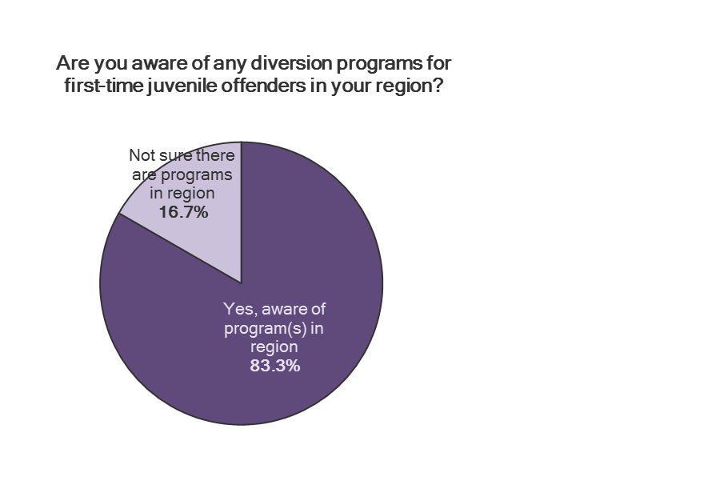
Diversion Program Awareness
Of the 13 regions responding, 10 regions (83.8%) reported being aware of diversion programs in their region, while two regions (16.7%) were not sure whether there were any programs and one region skipped the question.
Ten respondents were able to list at least one program in their region, while six also listed a second program. The following programs were listed:
ADAC , Responsible Decisions | Sullivan County | Nashua Youth Council | Nashua
Belknap Co Juvenile Diversion | Laconia | Prime for LIfe + | Manchester
Boomerang Diversion Program | Raymond | Restorative Justice | Plymouth
Child Family Services | not listed | Restorative Justice | Tamworth
Community Alliance | Newport | Rochester diversion | Rochester
Dover Teen Center | Dover | Seacoast Youth Services | Seabrook
Family Mediation Services | Atkinson | Upper Room | Derry
Merrimack Co. Juvenile Diversion | Franklin | Valley Diversion | White River Junction, VT
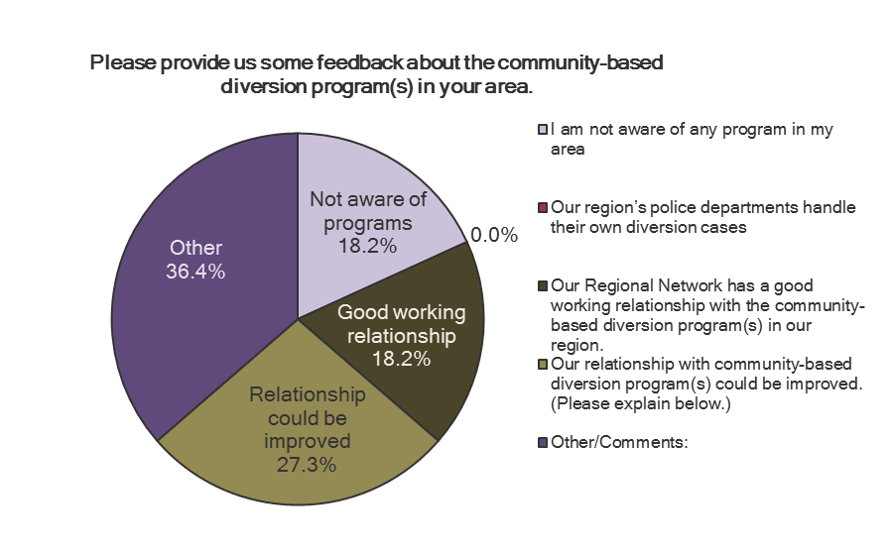
When asked to provide some feedback about the community-based diversion program(s) in their areas, 11 Regional Network Coordinators responded. Two respondents (18%) indicated that they have a good working relationship with community-based diversion, two (18%) were not aware of diversion programs, and three respondents (27%) indicated that their relationship with diversion could be improved.
Four respondents (37%) indicated “Other” and added the following comments:
“CADY operates the sole community-based diversion in our region.”
“We have an existing relationship with the diversion program, but because we are a new region it could be improved.”
“Just learning what's here.”
“The regional network works closely with both agencies and we have supported the promotion and awareness of both programs however, they still seem underutilized relative to the need. The Regional Network would love to find a better way to strengthen the capacity and utilization of these resources among police, community, and courts.”
Perception of Diversion Effectiveness
Providing data is an important way for community-based diversion programs to promote effectiveness to Regional Networks and other key stakeholders. Regional Network Coordinators were asked to respond with their sense of the effectiveness of community-based diversion.
Effectiveness of the community-based diversion program(s) in your region (N=10) | Number | Percent
Have not connected with our Regional Network | 3 | 27.3%
Occasionally attend Regional Network meetings | 2 | 18.2%
Frequently attend Regional Network meetings | 3 | 27.3%
Participated in regional planning efforts | 3 | 27.3%
Have utilized us to open communication channels with key community leaders | 1 | 9.1%
Requested letters of support or commitment for grant applications | 2 | 18.2%
Other/Comments: | 6 | 54.5%
Only one region of 10 that responded indicated that their community-based diversion program regularly provides outcome data showing its effectiveness (10%), while one additional region reported being able to access data. Three regions (30%) believe that their programs are highly effective, yet are unaware of any outcome data, while two (20%) are unclear whether their regional programs are effective. No one indicated that the overall sense in the region is that diversion programs are not effective.
Coordinators made the following comments:
“I am unaware if we are connected to our local diversion programs. However, I would welcome a discussion on how we may be able to collaborate.”
“The diversion program is highly supported and perceived as effective, but data is limited.”
Additional Models to Consider to Increase Effectiveness
Learning about other models of effective diversion programs can help improve the quality of the programs offered in New Hampshire. Regional Network Coordinators were asked to share any additional models they were aware of that should be further explored. Four ideas were offered:
- Shared Youth Vision with NH Employment Security can be a more collaborative extension of this from the perspective of both extended follow up and fully encompassing supports.
- One concern raised in our region is, can we effectively identify kids going through diversion that would be a more appropriate fit for treatment and get them to those resources?
- Restorative Justice Model up in the Plymouth Region ... I've heard good things about that program.
- Fee for service using medical billing.
Opportunities for Collaboration
Given that Regional Networks cover the entire state, they are able to serve as a resource for community-based programs as diversion programs are seeking to raise their visibility and sustainability. However, not all of the diversion programs participate in their Region’s efforts:
Regional Network Coordinator Response (n=11)  Our diversion program(s): | Number | Percent
Have not connected with our Regional Network | 3 | 27.3%
Occasionally attend Regional Network meetings | 2 | 18.2%
Frequently attend Regional Network meetings | 3 | 27.3%
Participated in regional planning efforts | 3 | 27.3%
Have utilized us to open communication channels with key community leaders | 1 | 9.1%
Requested letters of support or commitment for grant applications | 2 | 18.2%
Other/Comments: | 6 | 54.5%

The following additional comments were provided:
“Unsure - staff from diversion agency participates in some local SMP coalitions. Would welcome increased participation on regional level and with PH initiatives!”
“On behalf of Restorative Justice, CADY participated in prior regional network meetings and advocated for funding. The former regional network did not identify diversion as a regional strategy in its strategic planning efforts.”
“As a new Coordinator for the Region, I am unaware of how deeply connected (if so) we are with our local diversion programs.”
“Bridges to Prevention was substantially involved in advocating for financial support for the diversion program. We are a new region but are inheriting those relationships.”
“We are connected on a very minimal level - I am not sure they are aware of how the Regional Network System could be of assistance.”
“There is room for improvement in all these areas.”
It is important for community-based diversion programs to avail themselves of regional support.  Regional Network Coordinators responded that they are willing to provide assistance to community-based diversion programs in the following ways: | CADY | Capital Region | Carroll County | Communities United | Greater Derry | Greater Manchester | Greater Nashua | Monadnock | North Country | Lakes Region | Seacoast | Strafford | Upper Valley
Consult with diversion programs around accessing key community leaders and elected officials |  |  |  |  |  | No response provided
Host/facilitate meeting with key community leaders to promote diversion
Host/facilitate meeting with elected officials to promote diversion
Include diversion program outcomes in regional newsletter or web site
Include link to/blurb about diversion program on Regional Network web site
Include workshop on diversion programming during regional conference
Include funding for diversion program in regional grant proposal
Provide letters of support or commitment for grant applications
Additional Suggestions to Improve Visibility
When asked to provide addition suggestions as to how community-based diversion programs can increase their visibility and sustainability, five Regional Coordinators offered the following ideas:
“Continue building strong relationships locally and build legislative support for state funding of diversion.”
“More integrated collaboration. Still compartmentalized approach. Courts and police see diversion as an in and out remedy not understanding that there needs to be broader more comprehensive approach for many of these youth in order to be more successful. Need help to bring judicial and police systems to the well.”
“Right now we are exploring working with rural towns that may not currently use diversion due to transportation and other barriers. We also have identified working with law enforcement/diversion/treatment providers to improve the assessing of the treatment of kids that may have more severe/complicated issues.”
“Full coverage of County, use City Council and town selectmen and school boards to educate and seek funding.”
“During our substance misuse prevention task force meetings that the regions police departments and other law enforcement officials attend, we generally incorporate diversion groups into the agenda. We also ask diversion to host a meeting to highlight their organization.”
“Higher level state support to develop more integration would help.”

