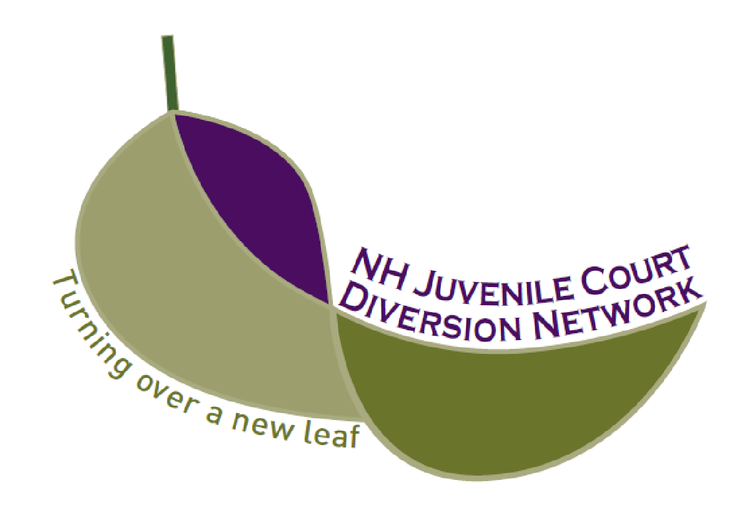

NH Juvenile Court Diversion Network

10 Ferry St., Suite 315
Concord, NH 03301

Office: 603-369-8250
www.NHCourtDiversion.org

Accreditation Questionnaire
Please read each section carefully, as the format and standards have been updated prior to January 2026.
Please read and check the statements below indicating your agreement:

☐ By submitting this form, I acknowledge that my Juvenile Diversion Program for juvenile offenders exists to promote and support community-based alternatives to the formal court process that:
- integrate restorative justice practices,
- promote positive youth development, and
- reduce juvenile crime and recidivism.

☐ I understand that I am required to notify the Executive Director of the NH Juvenile Court Diversion Network in the event of a major change in staffing or organizational leadership to ensure that the highest quality services continue.

☐ As an Accredited, Court-Approved Juvenile Diversion Program, I understand that the New Hampshire Juvenile Court Diversion Network expects a representative of my program to attend the bi-monthly Community of Practice (CoP) meetings. There are five CoP meetings per year; in addition to the Summit held in June and the voluntary Appreciation Event.

☐ I understand that applicable Accreditation fees are payable by June 30th of each year.

☐ I understand that if more than one Accredited program is operated under one agency, I must include this questionnaire and all related documents pertaining to each program.
Contact Information
Program Name |  | Website
Contact Name |  | Email
Title |  | Phone
Street Address |  | CEO/Director
City/State/ZIP |  | CEO Email
County
RSA 169-B requires that all Juvenile Diversion Programs must be court approved. This questionnaire is designed to provide the Administrative Judge of the Judicial Branch Family Division with sufficient information to consider your program a “Court Approved Diversion Program”.

- If your program complies with the standard, check “In compliance” and label and attach your documentation.

- If your program does not comply, check “See Plan.” Using a separate sheet, please provide the steps the agency will take to come into compliance with those areas identified as deficient. A short (2-3 sentences if you can) narrative will suffice.

Please submit your complete questionnaire, compliance plans and documentation binder to:
Diane Casale, NH Juvenile Court Diversion Network, The Concord Center, 10 Ferry Street, Suite 315 Concord, New Hampshire 03301

Juvenile Court Diversion Program Organization/Agencies
Section | Standard | In Compliance | See  Plan
1.1.0 | The program/organization providing “Court Approved” juvenile diversion services is a non-profit organization 501(c)(3) or a unit of government (town, city or county). | ☐ Ex: 501(c)(3) letter or annual report listing your program. | ☐
1.2.0 | The program/organization has a governing body (board of directors, board of selectmen, board of trustees or commissioners). | ☐ Ex: Updated board of directors list. | ☐
1.3.0 | The program maintains a written policy manual and/or employee handbook that clearly outlines governance processes — including decision-making, conflict resolution, and personnel practices which, whenever possible, reflect the values and principles of restorative justice. | ☐ Ex: Written anecdotal documentation of governance decisions made using restorative justice processes (e.g., case examples, narratives).  Interview data or testimonials from stakeholders confirming the use of restorative practices in decision-making and conflict resolution. | ☐
1.3.1 | The program will have written guidelines defining management of cases from referral through to completion that also detail the time frame and terms required for successful completion. | ☐ Ex: There is a written procedure or flow chart that identifies activities and time frames from referral to completion.  A compilation of case data indicates the time frames from referrals to intakes to restorative justice meetings to completion. | ☐
1.4.0 | The program subscribes to a code of ethical standards and practices. | ☐ Ex: Mission or value statement of organization. | ☐
1.5.0 | The program operates out of an office/facility that complies with all building and safety codes and is accessible to the handicapped or has access to the same. | ☐ Ex: Copy of an MOU with complying facility or Health Officer Inspection. | ☐
1.5.1 | The program will have a clear statement of values and principles of restorative justice available to the public. | ☐ Ex: Staff and volunteer job descriptions, narrative describing how a client is processed. | ☐
 | Employees/Volunteers
2.1.0 | The program will ensure confidentiality of the participants by providing a secure Virtual environment when using Zoom or other virtual applications for intakes, meetings, classes, etc. | ☐ Ex: Description of Zoom or other virtual applications protocol. | ☐
2.1.1 | The only individuals having direct contact with court diversion program participants are employees or volunteers of the agency/organization. | ☐ Ex: Staff and volunteer job descriptions, narrative describing how a client is processed. | ☐
2.2.0 | The program/organization has an application or resume on file for each of its employees and volunteers involved in juvenile diversion. | ☐ Ex: Application, written description of hiring process. | ☐
2.3.0 | The agency/organization conducts criminal background checks periodically on staff and sub-contractors who have one-on-one direct contact with juvenile diversion participants. All volunteers/interns will undergo a reference and criminal background check. | ☐ Ex: Written policy or copy of background check with identifiers removed. | ☐
2.4.0 | The program has written diversion employee job descriptions on file. | ☐ Ex: Description. | ☐
2.4.1 | The program has written volunteer/intern job descriptions on file. | ☐ Ex: Description. | ☐
2.4.2 | The diversion program’s leadership is consistent with restorative justice principles. | ☐ Ex. Interviews with staff or volunteers reveal restorative practices in supervision. | ☐
2.5.0 | The program has a process for evaluating staff assigned to the juvenile diversion program. | ☐ Ex: Staff evaluation form or completed form with identifiers removed. | ☐
2.6.0 | The agency/organization will have a signed oath of confidentiality form on file for all staff and volunteers associated with juvenile diversion. | ☐ Ex: Confidentiality form with identifiers removed. | ☐
2.6.1 | Staff will communicate confidentiality policies during the initial conversation with all the people who participate in their programs. | ☐ Ex: The program has a written confidentiality policy protecting information about people involved in its program. | ☐
2.7.0 | The agency/organization will have a volunteer form on file for all its volunteers that comply with RSA 508:17, (The Volunteer Immunity Law). | ☐ Ex: Volunteer application or position description. | ☐
Training/Staff Development
Section | Standard | In Compliance | See  Plan
3.1.0 | The program provides training/orientation for new staff and diversion volunteers. | ☐ Ex: Description. | ☐
3.2.0 | The program maintains a record of training provided to staff and volunteers. | ☐ Ex: Description. | ☐
3.3.0 | The program staff attends all training required by NH Juvenile Court Diversion Network. | ☐ Ex: Certificates. | ☐
Community involvement and partnerships
4.1.0 | The program follows a written procedure for transferring diversion cases to other jurisdictions or diversion programs. | ☐ Ex: Form available on website. | ☐
4.2.0 | The program can show evidence of community involvement in their juvenile diversion process. | ☐ Ex: List of volunteers, service sites, minutes, articles, social media. | ☐
4.3.0 | The program can show evidence that they have working relationships with local police and schools. | ☐ Ex: Current MOU’s, letters of support, or information sent to each PD/school from ALL school & police dept. | ☐
4.4.0 | The program can show evidence they collaborate and work with Assessment JPPO’S and traditional JPPO’s in their area. | ☐ Provide a narrative on ways in which you have engaged and collaborated with the JPPO’s in your area. | ☐
Financial
5.1.0 | The program has a regularly updated schedule of fees for the services they provide. | ☐ Ex: Schedule of fees. | ☐
5.2.0 | The program has an annual operating budget that is approved by its governing body. | ☐ Ex: Most recent budget. | ☐
5.3.0 | The program/organization has obtained an audit or a financial review showing revenues and expenditures for diversion programming. If applicable, has filed a Form 990 and state filing as required by RSA 7:28. | ☐ Ex: Audit, financial review, Federal form 990, State form NHCT-12 for most recently completed fiscal year. | ☐
5.4.0 | The program can show that it maintains a liability insurance policy that covers its governing body, employees, volunteers, and diversion related programs. | ☐ Ex: Copy of liability Insurance page. | ☐
Record Keeping
Section | Standard | In Compliance | See  Plan
6.1.0 | The program has a mechanism for evaluating the effectiveness of their program as well as any referral provided. | ☐ Ex: Questionnaires, closeout survey. | ☐
6.2.0 | The program maintains and reports via RedCap Database all active and closed juvenile diversion cases by the 5th of the following month. | ☐ Ex: Current data updated in RedCap Database | ☐
6.2.1 | The Program collects the following information and submits to NH Juvenile Court Diversion Network’s evaluated quarterly. | ☐ Ex: Description, program additions as necessary. | ☐
  - Program Name ID  - Participant’s name  - Date of Birth  - Gender  - Ethnicity  - Race  - Offense Date  - Reason for Referral  - Level of Offense | - Offense/Charge Category  - Referral Date  - SBIRT Screening Date  - SBIRT Results  - Restorative Interventions (if utilized)  - Date of Completion  - Completion Status
6.3.0 | The program produces a report to stakeholders. Please submit your most recent monthly/quarterly/annual report. | ☐ Ex: Most recent report. | ☐
6.4.0 | The program follows all applicable laws regarding privacy, storage and destruction of client records. | ☐ Ex: Description. | ☐

This next section has been completely revised to reflect Restorative Justice principles and values. Please read each item carefully, along with the corresponding response options, and check the box that most accurately describes your current practice and provide documentation.

Diversion Program Components

Section | Standard | 1 | 2 | 3 | 4
Doing With
7.0.0 | The program will strive to employ the principle of doing “with” youth instead of “to” or “for” in all its practices so that goals, case plans, progress assessments, etc. are defined with maximum input of the program participants. | ☐ Staff and volunteers are decision-makers; participants have little to no minimal input. | ☐ Participants may be asked for input during the process but there is little evidence that it informed the process or the contract. | ☐ Participants have input during the process, it informs the process and agreements, but the agreements are ultimately created by volunteers and staff. | ☐ Participants indicate that their input mattered throughout the process.  Participants feel they had input into and co-created their agreements.  Provide documentation.
Referral & Intake
Section | Standard | 1 | 2 | 3 | 4
7.1.0 | The program has written eligibility guidelines for participation in diversion. | ☐ This is not in place. |  |  | ☐ This is fully in place.  Provide redacted documentation.
7.1.1 | The program has a written juvenile diversion referral process including a referral form. | ☐ This is not in place. |  |  | ☐ This is fully in place.  Provide written process.
7.1.2 | The program has a participation agreement form containing the following 3 sections or wording with the same intent:  ___In the event this case is referred to for a court disposition I acknowledge that information could be shared with the court, police, prosecutor and juvenile probation officer to assist in my disposition and rehabilitation.  ___ I give my permission to the (Diversion Program) to contact me or my parents/guardians up to 5 years after my successful completion of diversion to follow-up on my overall progress.  ___ I give permission to the Diversion Program to contact any individuals who have been impacted by the offense that led to my referral. | ☐ This is not in place. |  |  | ☐ This is fully in place.  Provide redacted form.
7.1.3 | The program has a confidential release of information form. | ☐ This is not in place. |  |  | ☐ This is fully in place.  Provide redacted form.
Screening & Assessment
Section | Standard | 1 | 2 | 3 | 4
7.2.0 | The program utilizes the NHJCDN SBIRT screening tool (S2BI and PHQ-2). | ☐ This is not in place. |  |  | ☐ This is fully in place.  Provide copy of filled out form.
7.2.1 | The program has a diversion intake or client screening/ information containing questions in the 6 categories listed below.  a. School history  b. Substance use history  c. Mental & physical health history  d. Family dynamics/history  e. Previous police contact  f. Connectedness/activities/  interests | ☐ This is not in place. |  |  | ☐ This is fully in place.  Provide copy of intake form.
7.2.2 | The program can provide a list of community resources available to children and their families. | ☐ Limited to no awareness of current community resources. | ☐ The program has a list of community resources that has not been updated in the last 3 years. | ☐ The program has a current list of community resources, but limited relationships with contacts. | ☐ The program has a current list of community resources, can demonstrate a relationship with most entities on the list, and can facilitate a "warm handoff” if desired.  Provide list with contact names and numbers.
Harmed Party Outreach & Engagement
Section | Standard | 1 | 2 | 3 | 4
7.3.0 | The program will ensure that outreach procedures exist for contacting people identified as affected by wrongdoings in referrals. | ☐ No documented procedures; no evidence that harmed parties have been contacted. | ☐ Policies and procedures for contacting harmed/affected parties are vague or not followed. Case files reveal no to minimal effort to contact harmed/affected parties. | ☐ Policies and procedures for contacting harmed/affected parties exist. Case files reveal some attempts to contact parties and the results of those attempts. | ☐ There are clear policies and procedures for contacting harmed/affected parties. Case files reveal that contacts have been made with harmed/affected parties.  Provide policies.
7.3.1 | The program will listen to, and support harmed/affected parties’ wants and needs whenever possible and consistent with restorative principles and values. | ☐ No documented procedures; no evidence that harmed parties have been listened to. | ☐ Procedures around working with harmed parties are vague or not followed. Case files reveal minimal communication with harmed/affected parties. | ☐ Procedures for working with harmed/affected parties exist.  Case files reveal some communication with harmed parties and some examples of input informing contracts/agree-ments. | ☐ Case notes document contact with harmed/affected parties, how they were impacted, and what they need.  Evidence of invitations to participate in a restorative process.  Notes w/ name redacted.

Restorative Panel Process
Section | Standard | 1 | 2 | 3 | 4
7.4.0 | The program will provide harmed/affected parties with meaningful opportunities to participate, tell their story, and make decisions in restorative processes, including choosing their level of involvement. | ☐ No documented procedures: no evidence that harmed parties have been offered an opportunity to be involved. | ☐Procedures around harmed party participation are vague or not followed.  Case files reveal minimal to no indication that harmed parties have been offered meaningful opportunities to participate. | ☐ Procedures for working harmed/affected parties exist.  Case files reveal harmed parties who have been offered meaningful opportunities to participate and the level of involvement that they chose. | ☐ Case notes show harmed/affected parties have been involved in restorative processes.  Redacted contracts show harmed/affected parties’ involvement.  Notes w/ name redacted.
7.4.1 | Restorative Processes will maximize active participation of responsible parties to tell their story and make decisions in the crafting of restorative solutions. | ☐ There are no indicators of the program creating conditions for active participation of the party responsible. Some process procedures may discourage active participation. | ☐ There are few clear indicators of the program creating conditions for active participation. The process neither discourages nor encourages active participation. The participant needs to self-advocate to meaningfully participate. | ☐ Program communicates that having an active, collaborative role in the dialogue and decision making is desired. Process creates the conditions for active participation (e.g. intentional relationship building).  At least 60% of participant surveys indicate they perceive having had a meaningful, decision-making role in the restorative justice process | ☐ Program guidelines demonstrate and communicate to participants that having an active, collaborative role in the dialogue and decision making is desired. Process creates the conditions for active participation (e.g.collaborative agreement development).  Participant surveys consistently indicate they perceive having had a meaningful, decision-making role in the restorative justice process.  Notes w/ name redacted.
7.4.2 | The program can show that they incorporate the following restorative justice principles into the development of diversion contracts:  1) Deepen understanding of the harm.  2) Make amends to the people impacted by the wrongdoing.  3) Form a positive connection with the community.  4) Address the conditions that contributed to the "wrongdoing".  Name redacted contract. Narrative of meeting process. | ☐  Contract/agree-ments do not focus on the harm.  Contracts primarily contain conditions likely to be perceived as punitive or aimed at 'fixing' the participant. | ☐ Contract/agree-ments focus on the harm as perceived by staff and volunteers (not those most directly impacted).  Volunteers and Staff may see agreements as restorative; participants likely experience the contract as punitive or aimed at 'fixing' the participant. | ☐ Contract/agree-ments demonstrate an effort to understand, acknowledge, and address the harm; form positive connections; and address underlying factors.  However, agreements across the program tend to be very similar (a.k.a. cookie cutter). | ☐ Review of contracts/agreements clearly demonstrate an effort to understand, acknowledge, and address the harm; form positive connections; and address underlying factors.  Contracts are creative and tailored to the individuals, circumstances, and unique needs.
7.4.3 | The program utilizes a signed diversion contract with restorative agreements on file for all juvenile diversion participants. | ☐ Contracts are finalized prior to restorative process; not personalized; many are identical from case to case. | ☐ Participants may be asked for input during the process.  The contract is negotiated and finalized by staff and volunteers without the participant in the room. | ☐ Participants have input during the process that inform the agreements.  Final agreements are created by volunteers and staff. | ☐ Participants indicate their input mattered throughout the process.  Participants feel they had input into and co-created their agreements.  Evaluation survey
7.4.4 | The program documents all contact they have with juvenile diversion program participants, parents or others involved during the entire juvenile diversion process. | ☐ This is not in place. |  |  | ☐ This is fully in place.  Redacted contact  logs for duration of agreement.
7.4.5 | Diversion staff support responsible parties to successfully complete their restorative agreements. Flexibility with deadlines is encouraged; as long as, the responsible party is proactively engaged. | ☐ Rigid deadlines demonstrated by failure or indication of successful completions without clear documentation of fulfilling the agreements in the contract. |  |  | ☐ Contracts and contact records demonstrate the length and continuation of a process which shows increments of achievement by the responsible party.  Name redacted contact logs.
7.4.6 | The program has a process for exiting juvenile diversion participants from the program upon completion of their respective contract obligations. | ☐ This is not in place. |  |  | ☐ This is fully in place.  Copy of policy
7.4.7 | The program will assess participant perceptions of their experiences in their diversion process and whether restorative principles were upheld in the process. | ☐ No indication that the program collects information from participants about their experience. | ☐ Program collects information from the participant, but it does not include a way to assess the perception around restorative principles being upheld. | ☐ Program uses a tool to assess the participant’s experience with Diversion and perceptions around restorative principles. Data is not used in a meaningful way. | ☐ Program consistently uses a tool to assess the participant’s experience with Diversion and perceptions around restorative principles. Data is compiled, shared, and informs program development.  Copy of Survey
7.4.8 | The program provides written notice of completion to all referral sources. | ☐ This is not in place. |  |  | ☐ This is fully in place.  Copy of notice names redacted.
Diversion Program Components
Section | Standard | In Compliance | See  Plan
7.5.0 | The program can show evidence that they offer meaningful community engagement opportunities for youth participating in juvenile diversion. | Ex: MOU with community sites, list of sites, list of hours provided, pictures of projects
7.6.0 | The program ensures diversion participants have access to educational opportunities that promote understanding and healing related to Mental Health and Substance Use, either directly or through referral partnerships. | Ex: list of services offered or referral sources.
7.7.0 | The program completes and maintains a copy of each participant’s case closing/completion letter. | Ex: Include form
7.8.0 | The program can provide a list of community resources available to children and their families. | Ex: Include sample

Signature Page

I agree that the information cited above and included in this application is true and current and is a fair representation of the operations of this juvenile diversion program.

Program Name: ______________________________________________________________________

Program Representative: Signature: _________________________________________
Name: ____________________________________________
Title: _____________________________________________
Date: ________________________________

Board Chair, Executive Director, Police Chief, or governing body equivalent:

Signature: ________________________________________
Name: ____________________________________________
Title: _____________________________________________
Date: ________________________________

Please contact Diane Casale, Diversion Accreditation, with any questions at diane@nhcourtdiversion.org or call at (603) 369-8225

